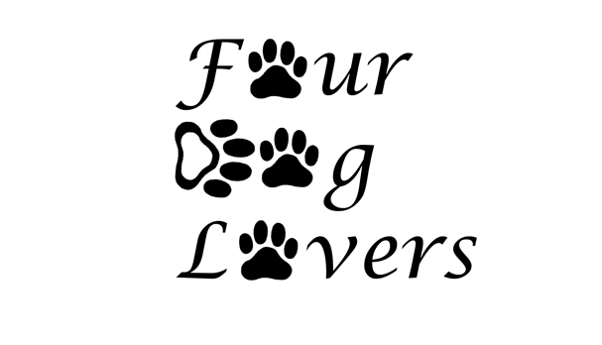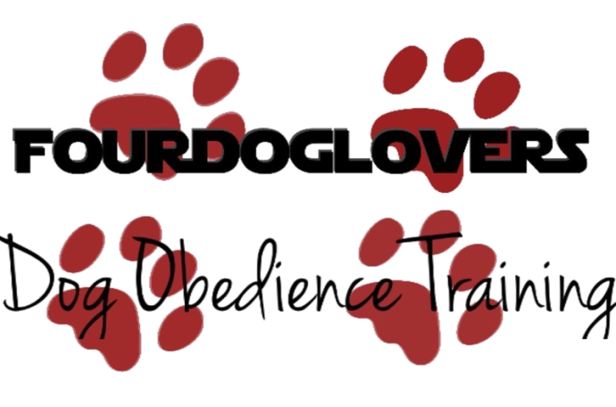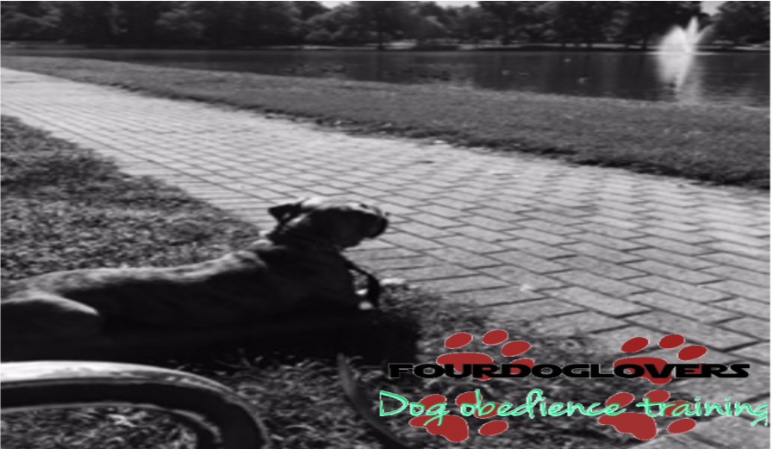
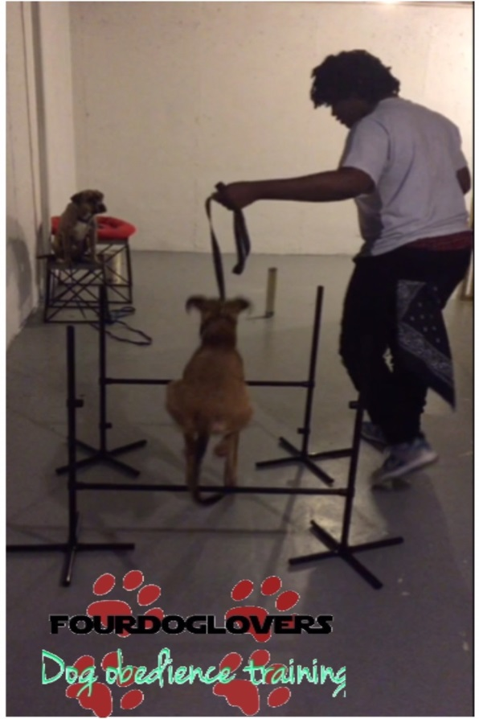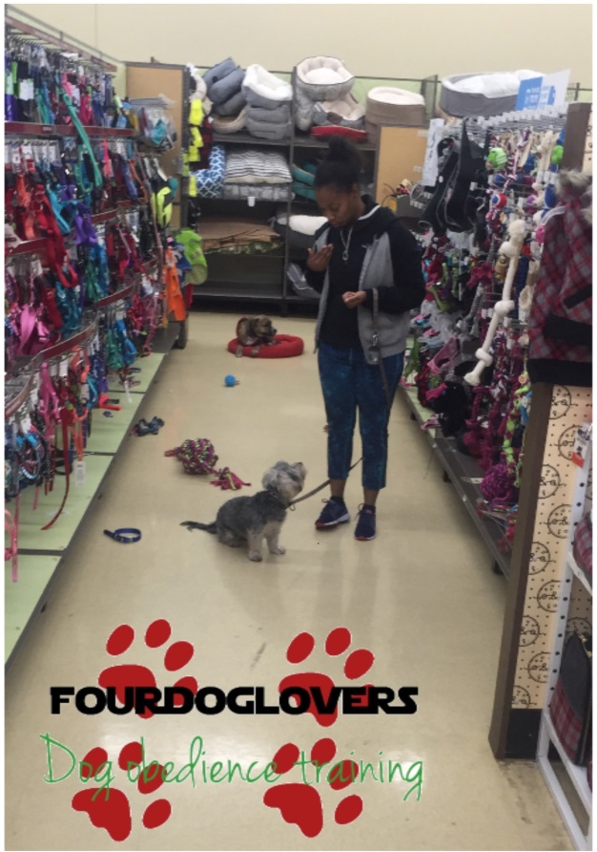

FourDogLovers is here to help you with your dog related needs!
Name: ___________________________________________________________
Phone Number: ____________________________________________________
Email: ___________________________________________________________
Address: ____________________________________________________________
Dog Name: ____________________________________________________________
Dog Age/Dog Breed/Color/Gender: _______________________________________________
History of biting: _______________________________________________________________
Known Illnesses: _____________________________________________________________
Notes:

Obedience Training
In home dog or puppy training, fitness, behavior corrections based off of you and your dog/puppy individual needs. Ages range from 3 months and beyond, no dog is too old to learn. Each Session is about an hour thirty- 2 hours long with induvial class time after every session. Homework will be simply what was done in class each week. So seriousness and consistency is a must. Every package is a month long with more classes offered every month. Training never ends after the package is over but result will show in just one month. Repetition is the father of learning so practice makes perfection.
Puppy socialization
All dogs need proper socialization which starts once they are born. It is vital that at an early age they start exploring the world, people, other dogs and puppy, and animals, and more. This will give them a positive look on the world around them, dogs, and help form a great outlook for their adult dog hood.
Dog walking
Walking your dog is key to the fulfillment, training, and bonding that your puppy will need. It is not on everyone top to do list and sometimes people can be a bite busy. No worries I offer afternoon/night walks for your puppy or dog.
Fitness
Dog fitness is no joke! Every dog from a Teacup Yorkie to a Great Dane needs fitness and exercise. Dogs have Joints, Tendons, Ligament, and Muscles that are not being worked lying up in our homes. Dogs are wild animals, carnivores to be exact they got their work out from hunting their prey. Fast forward to present day supper markets their prey is a food bowl. Fifteen minutes a day, every day is a great way to start and build stamina to last for hour workouts
This Contract is effective as of _________________________, (Date)
by and between Kevin Oyetimbo of Fourdoglovers, and ________________________________ ______________________________________________________________________________
___________________________________________________. (All owners responsible for dog/puppy)
Whereas __________________________________________________________ (Your Name) wishes to engage in ________________________________________________(List of services) and I Kevin Oyetimbo agrees to undertake the services under the terms and provisions defined in this Contract as well as ____________________________________________’s (Your Name) Information sheet, Pet information sheet, and Veterinary release form which is a part of this contract.
Description of services: Beginning on _______________________ (Date), Kevin Oyetimbo will provide exceptional ____________________________________________ (services) service for ________________________________________________________ (Dog(s) name) and ______________________________ (Your Name).
Payment for service: _____________________________________________ (Your Name) shall pay the amount of _________________________ to Kevin Oyetimbo on or before the date of service listed above. Additional fees may include the purchase of necessary items for the care of the pet, including but not limited to pet food, cleaning supplies, transportation, unexpected visits and emergency expenses for health care. I Kevin Oyetimbo will retain and show proof of receipts for additional expenses.
The full amount will be paid and payment of all additional fees or expenses effected within 14 days of end of service.
Term/termination: This service will terminate automatically on___________________________.
Choose one: Pick up____________ Drop off__________.
NO shows/abandonment will result in safe transportation to nearest animal shelter.
Emergencies: In the event of an emergency, I Kevin Oyetimbo shall contact _____________________________________________________ (Emergency contact/number) at the number provided to confirm _____________________________________’s (Your name) choice of action. If ________________________________ (Emergency contact 1) cannot be reached in a timely manner, _____________________________ (Emergency contact 2/Number) is authorized to:
- Transport the pet(s) to listed veterinarian on the attached Release Form;
- Request on site treatment from a veterinarian;
- Transport the pet(s) to an emergency clinic if the previous two options are not feasible.
Relationship of parties: It is understood by the parties that Kevin Oyetimbo is an independent contractor with respect to_____________________________________________ (Your name) and not an employee of ______________________________________________.(Your name) ________________________________________(Your name) will not provide fringe benefits, including health insurance benefits, paid vacation, or any other employee benefit, for the benefit of Kevin. ___________________________________(Your name) is entitled to pay any medical bills that may occur during time of service is active.
Security: Kevin Oyetimbo warrants to keep safe and confidential of all keys, remote control entry devices, access codes and personal information of __________________________________________ (Your Name) and to return the same to ______________________ (Your Name) at the end of the contract period or immediately upon demand.
Indemnification: The parties agree to indemnify and be held responsible for each other personal property assigned to any and all clam losses, expenses, fees including attorney fees.
Liability: Kevin Oyetimbo accepts no liability for any breach of security or loss of damage to _________________________’s (Your Name) property if any other person has access to the property during the term of this contract. Kevin Oyetimbo shall not be liable for any mishap of whatsoever nature which may befall a pet or caused by a pet who has unsupervised access to the outdoors. Kevin Oyetimbo is released from all liability related to transporting pets to and from any veterinary clinic or kennel, the medical treatment of the pet(s) and the expense thereof. Kevin Oyetimbo is released from all liability of injury to pet(s) caused by other pet(s) or animal(s) not under the control of Kevin Oyetimbo.
Entire Agreement: This Contract contains the entire agreement of the parties, and there are no other promises or conditions in any other agreement whether oral or written.

Veterinary and Vaccination Form
Vet name: __________________________________
Vet Phone:___________________________________
Rabies: ________________________________________
DHPP: ________________________________________
Parvo: _________________________________________
Bordetella: _______________________________________

